Azerbaijan in all its colours
7 nights
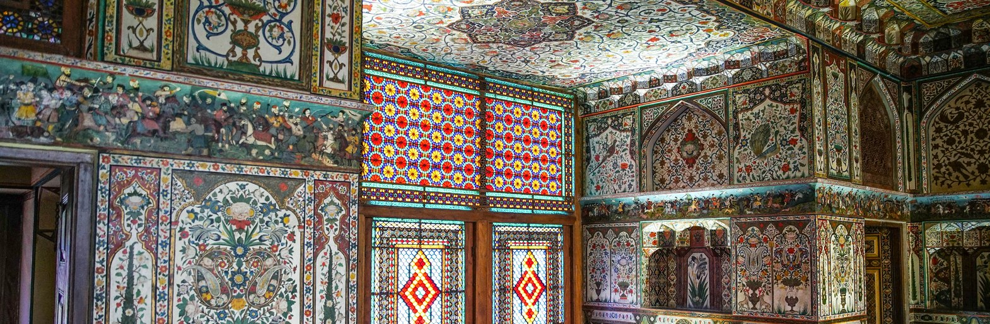
Guaranteed departure dates
No departures are currently published for this language.
// Day 1: Arrival in Baku
Arrival at Baku airport. Optional transfer to the hotel and overnight in the city.
The tour starts at 09:15.
// Day 2: Baku – Gobustan – Baku
Breakfast and departure for Gobustan, around 60 km from Baku. Gobustan’s UNESCO-listed rock-art landscape preserves thousands of engravings on the boulders of a semi-desert plateau. Hunters, wild animals, boats and groups of dancers record how successive communities lived, travelled and expressed their beliefs. The museum explains these images in the context of prehistoric settlements and changes in the environment, making the small figures on the stone easier to understand.
Visit the Gobustan Museum to discover the region's rock art. Return to Baku and walk through Icherisheher, the Old City, among historic buildings and former residences of the oil barons. Icherisheher is Baku’s inhabited walled city, recognised by UNESCO together with the Shirvanshahs’ Palace and Maiden Tower. Its narrow lanes connect mosques, caravanserais and bathhouses that served the medieval trading town. The fifteenth-century palace complex was the royal residence of the Shirvan rulers; the cylindrical Maiden Tower, with its thick stone walls, is one of the city’s oldest landmarks. Their architecture shows Baku’s history before the oil boom reshaped the surrounding streets.
Visit the Palace of the Shirvanshahs, the Maiden Tower, the ruins of St Bartholomew's Church, the old hammam and historic mosques. Lunch included. Dinner at leisure and overnight in Baku.
// Day 3: Baku – Absheron Peninsula – Baku
Breakfast and a visit to the Baku viewpoint overlooking the Caspian bay. Excursion to the Absheron Peninsula to visit the Ateshgah Fire Temple in Surakhani and Yanar Dag, the Burning Mountain. Ateshgah’s stone enclosure surrounds a central fire altar and the small cells once used by pilgrims. Its inscriptions and courtyard recall the Hindu and Sikh merchants who travelled to Absheron, alongside the region’s older fire-worship traditions. The surviving complex largely dates to the seventeenth and eighteenth centuries, when Baku’s trade routes brought visitors from the Indian subcontinent. At Yanar Dag, natural gas escaping through the hillside feeds a line of flames at the base of the rock. The fire comes from the ground rather than a volcanic eruption, offering a visible explanation of Azerbaijan’s “Land of Fire” name. The low ridge and exposed rock make the phenomenon easy to distinguish from the fire altar at Ateshgah.
On returning to Baku, visit the Heydar Aliyev Center (exterior visit only), designed by Zaha Hadid, and Yashil Bazaar, known for fresh produce, spices and local specialities. Zaha Hadid’s Heydar Aliyev Center is recognised by its continuous white curves: the building’s surface rises from the plaza and folds into the roof, avoiding the straight lines of a conventional façade. From outside, the changing angles reveal how the architecture and landscaped space form one composition. This stop concerns the exterior, without promising entry to the exhibitions. Yashil Bazaar’s stalls display seasonal fruit, herbs, nuts, dried fruit and fragrant spices. Pomegranates, tea and preserves are among the products associated with Azerbaijani kitchens. The market shows how produce from different regions reaches Baku and offers a close look at everyday shopping, from stacked baskets of fruit to the small stalls of pickles and local specialities.
Lunch included and overnight in Baku.
// Day 4: Baku – Shamakhi – Kish – Sheki
Breakfast and departure for Sheki. On the way, visit the Diri Baba Mausoleum in Maraza and the Juma Mosque in Shamakhi. Built in 1402, Diri Baba is a two-storey mausoleum set directly against a rocky hillside. Its compact stone façade, arched openings and domed chamber belong to the Shirvan–Absheron architectural tradition. The unusual position makes the building appear to grow out of the cliff, while local legends explain its long history as a place of pilgrimage. Shamakhi’s Juma Mosque traces its foundation to the eighth century and is one of the country’s earliest Islamic monuments. Earthquakes and rebuilding have marked its history, so the present structure combines restored architecture with a much older place of worship. Its spacious prayer halls and domes introduce the religious heritage of the former Shirvan capital.
Lunch during the journey. Visit the church of Kish and Sheki's historic centre, linked to the Silk Road and the region's craft traditions. Kish’s stone church stands in a village at the foot of the wooded mountains near Sheki. Its domed silhouette and compact interior introduce the Christian heritage associated with ancient Caucasian Albania, a historical kingdom unrelated to present-day Albania. The museum setting explains the building’s successive periods and the archaeological finds around it.
Tour the Palace of the Sheki Khans, known for its coloured stained glass and wall paintings. Sheki’s historic centre and Khan’s Palace form a UNESCO World Heritage property shaped by the Silk Road, silk production and trade. Merchant houses and caravanserais reflect the town’s commercial past. Inside the eighteenth-century palace, floral paintings and hunting scenes cover the walls; shebeke windows combine small pieces of coloured glass and fitted wood without nails or glue. Sunlight projects their geometric patterns into the rooms, revealing the skill of local craftsmen.
Overnight in Sheki.
// Day 5: Sheki – Goygol – Ganja
Breakfast and a visit to Sheki bazaar. Continue to Goygol to see the German quarter and the Lutheran church. The town of Goygol grew from Helenendorf, founded in 1819 by settlers from Württemberg. Straight streets, houses with gardens and the Lutheran church preserve traces of that community. This heritage concerns the town and its former German quarter; it is distinct from Lake Goygol and the national park, whose visit depends on the actual itinerary.
Lunch en route, followed by departure for Ganja. Visit the Juma Mosque, the Imamzadeh Mausoleum and the city's caravanserais. Overnight in Ganja.
// Day 6: Ganja – Baku
After breakfast, return to Baku with a stop at the mausoleum of the poet Nizami. Nizami Ganjavi, the twelfth-century poet associated with Ganja, is renowned for the Khamsa, a cycle of five narrative poems. His stories combine love, ethics, legends and portraits of rulers, and have inspired manuscript illustration across the region. The mausoleum commemorates this literary heritage and Ganja’s place in the cultural history of the Caucasus.
Arrive in the afternoon and enjoy free time to explore the city or rest. Lunch included and overnight in Baku.
// Day 7: Baku: art, museums and the seafront
After breakfast, visit the YARAT contemporary art space and the Carpet Museum. The Carpet Museum’s rolled-carpet shape announces the collection inside. Regional weaving traditions can be distinguished through their colours, geometric borders and floral motifs; flat-woven pieces and knotted carpets show different techniques. The displays explain the role of carpets in homes and ceremonies, turning a familiar decorative object into a record of local craftsmanship. YARAT presents contemporary art in a converted industrial building by the waterfront. Exhibitions use painting, installation, photography and moving images to explore modern life and ideas from Azerbaijan and the wider region. It offers a different perspective from the historical collections elsewhere in Baku, with the particular works varying as exhibitions change.
Walk along the Caspian seafront boulevard and have lunch at a local restaurant. In the afternoon, visit the National Museum of History of Azerbaijan and the house of Haji Zeynalabdin Taghiyev. The National History Museum occupies the former mansion of oil entrepreneur and philanthropist Haji Zeynalabdin Taghiyev. Archaeological objects, weapons, coins and household items trace different periods of Azerbaijan’s history. The restored family rooms also show how Baku’s oil wealth was expressed in decorated ceilings, reception halls and the furnishings of a late nineteenth-century residence.
Return to the hotel and overnight in Baku.
// Day 8: Departure from Baku
Breakfast at the hotel and free time until the airport transfer, according to the flight schedule. Rooms must be vacated before 12:00.

